**Exercise 2**

**Description of Site Templates for SharePoint 2013**

**Team:**

A SharePoint team site connects you and your team to the content, information, and apps you rely on every day. For example, you can use a team site to [store and collaborate on files](https://support.office.com/en-us/article/what-is-a-document-library-3b5976dd-65cf-4c9e-bf5a-713c10ca2872) or to [create and manage lists of information](https://support.office.com/en-us/article/what-is-a-list-in-sharepoint-93262a88-20ad-4edc-8410-b6909b2f59a5). On a team site home page, you can view links to important team files, apps, and web pages and see recent site activity in the activity feed. You can access your team site from the [SharePoint Home page](https://support.office.com/en-us/article/find-news-sites-and-portals-in-sharepoint-6b85097a-87e0-4611-a29a-dfd49b1a1220), from the Files section of your Office 365 group if Office 365 Groups is enabled, or on the go with the [SharePoint mobile apps](https://support.office.com/en-us/article/sharepoint-mobile-apps-4891980d-5e53-4d7d-8408-737730992a62). You can also [find your SharePoint files in OneDrive](https://support.office.com/en-us/article/find-your-sharepoint-files-in-onedrive-for-business-9275de7b-0b0b-40ee-8fa2-b17d1b0727d0).

**Blog:**

A blog is a Web site that enables you or your organization to quickly share ideas and information. Blogs contain posts that are dated and listed in reverse chronological order. People can comment on your posts, as well as provide links to interesting sites, photos, and related blogs. Blogs posts can be created quickly, and they often have an informal tone or provide a unique perspective. Although blogs are frequently used for commentary on the Internet, they can be used in several ways in a corporate environment.

**Project:**

The project site template is designed to help you plan the work that needs to be done, collaborate with teammates, and collect project files and documents. Your project sub-site will come with basic Web Parts, such as Project summary timeline, a document library, and a Newsfeed to communicate with your team on the main page. You also have a notebook, tasks and a calendar to work with. The rest of these sections can help you plan, work with, and share your project with others.

**Community Site:**

A SharePoint online community is a virtual place where ideas are discussed and shared. It promotes open communication by fostering discussions among users who both share their expertise and learn from others. Active participation is encouraged through a reward system that recognizes members for their level of activity and quality of engagement.

**Sources:**

https://support.office.com/en-us/article/What-is-a-SharePoint-team-site-75545757-36c3-46a7-beed-0aaa74f0401e

https://support.office.com/en-us/article/Create-a-blog-2B3F0891-01B0-4785-9E8C-9B09BA29921F

https://support.office.com/en-us/article/Get-started-with-a-project-site-8B68274B-622D-4A99-9245-1D205897CD43

https://support.office.com/en-us/article/Create-a-community-8B6BB936-7EBC-4E60-B8AB-2D4897499AF9

**Exercise 2**

Description of the default permission levels in SharePoint

|  |
| --- |
|  |
| |  |  |  |  | | --- | --- | --- | --- | | Permission Level | Description |  |  | | http://bissp/_layouts/15/images/blank.gif?rev=23 |  |  |  | | [Full Control](http://bissp/Olanrewaju/AsteroidsGame/_layouts/15/editrole.aspx?role=Full%20Control) | http://bissp/_layouts/15/images/blank.gif?rev=23Has full control. |  |  | | [Design](http://bissp/Olanrewaju/AsteroidsGame/_layouts/15/editrole.aspx?role=Design) | http://bissp/_layouts/15/images/blank.gif?rev=23Can view, add, update, delete, approve, and customize. |  |  | | [Edit](http://bissp/Olanrewaju/AsteroidsGame/_layouts/15/editrole.aspx?role=Edit) | http://bissp/_layouts/15/images/blank.gif?rev=23Can add, edit and delete lists; can view, add, update and delete list items and documents. |  |  | | [Contribute](http://bissp/Olanrewaju/AsteroidsGame/_layouts/15/editrole.aspx?role=Contribute) | http://bissp/_layouts/15/images/blank.gif?rev=23Can view, add, update, and delete list items and documents. |  |  | | [Read](http://bissp/Olanrewaju/AsteroidsGame/_layouts/15/editrole.aspx?role=Read) | http://bissp/_layouts/15/images/blank.gif?rev=23Can view pages and list items and download documents. |  |  | | [Limited Access](http://bissp/Olanrewaju/AsteroidsGame/_layouts/15/editrole.aspx?role=Limited%20Access) | Can view specific lists, document libraries, list items, folders, or documents when given permissions. |  |  | |

Checking Permission Levels

1. Go to **Settings** Office 365 Settings button > **Site Permissions**.
2. Click **Site permissions.**
3. On the Permissions tab, click **Check Permissions**.
4. Enter the name or e-mail address in the space provided**.**
5. Click **Check Now**.

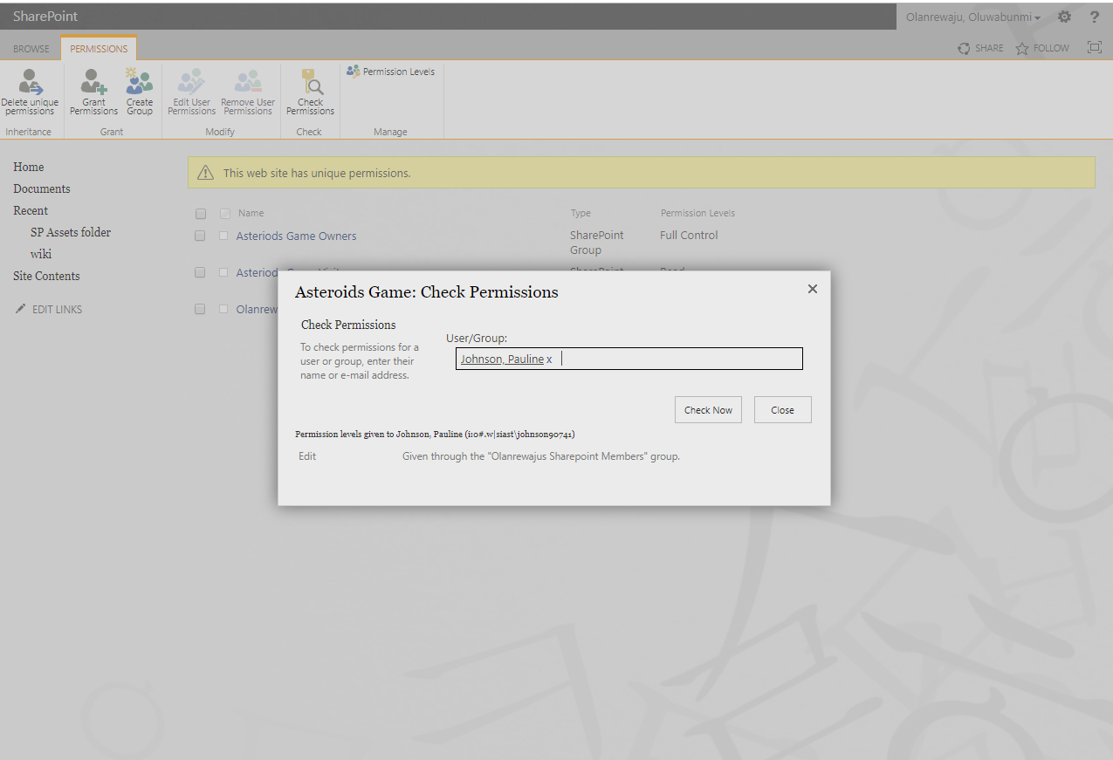

**Exercise 3:**

The process of emailing a link from the document library’s library tab to another

1. Go to **Documents**
2. Open Menu of the document needed
3. Copy the link (as seen in figure below)

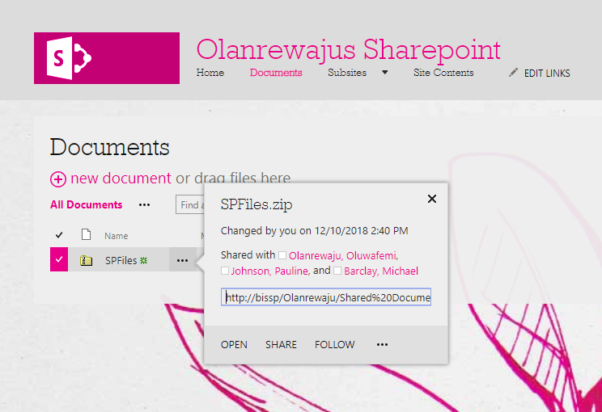

1. Email the link

Why Emailing a link to a document in a document library is better for document management than emailing a file as an attachment

Large File Size: There is limitation to maximum attachment size when sending or receiving a file. There are situations when recipient cannot open attachment due to the size of the files, so when you send the URL in the email, you simply do not have this issue anymore.

SharePoint is designed to help busineses manage their business data by organizing information into:

* Lists
* Libraries

It facilitates collaboration on documents, effective document management, and the easy production and sharing of information as Web content.

It is similar in principal to a database in that it is a central repository for shared information.

**How to use this wiki library**  
You can use this wiki library to share knowledge, brainstorm ideas, collaborate with your team on a design, create an instruction guide, build an encyclopedia of knowledge, or just write down daily information in an easily accessible and modifiable format.  
  
**Editing pages**  
To edit this page, click on the **Edit Page** icon at the top of the page. To see all available commands, click on the **Page** tab. When you are editing, you can type text onto the page or insert tables and pictures. To stop editing, click the **Save** button at the top of the page. If you leave the page while editing, you will be prompted to save your changes.  
  
**Creating wiki links**  
You can link to another page in this wiki library by enclosing the name of the page in double brackets. When you type [[, the wiki will suggest page names that start with what you've typed. You can select one of these pages using the arrow keys or the mouse, or you can type in a new name. If you type in a new name, it will make a link to a page which has not yet been created. Links are finished by typing ]]. If you are linking to a page in a subfolder or an item in another list, you can press tab to add the selected suggested item to your link without closing the link.  
  
You can link to many objects in SharePoint, not just pages. Here are some examples of links:  
[[Dogs]] : A link to a page named Dogs in the same folder.  
[[Animals/Dogs]] : A link to a page named Dogs in a subfolder called Animals.  
[[List:Announcements/Welcome]] : A link to the item called Welcome in the Announcements list on this site.  
  
To create a link to a page and have the link display different text than the page name, type a pipe character (|) after the page name, and then type the display text. For example, type [[Home|Home Page]] to create the link labeled Home Page that points to the page named Home.  
  
To display double opening or closing brackets without making a link, type a backslash before the two brackets. For example, \[[ or \]].  
  
**Creating pages**  
There are two main ways to create a new page in your wiki library:

1. Create a link to a page which does not exist and then click on it to create the page:  
   This is the recommended way to create a page because it is easier for people to find the page when another page links to it. Links to pages that do not yet exist have a dashed underline.
2. Create a page that is not linked to any other:  
   In the **Settings** menu, click **Add a page**. This will ask you for a name and then create that page in the current wiki library.

**Managing your wiki library**  
You can manage the pages in your wiki library by clicking **View All Pages** on the **Page** tab of any page in the library.  
  
**Restoring a page**  
If you need to restore a previous version of a page, click **Previous Versions** in the **Page** tab at the top of the page. You can then click on any of the versions in the quick launch to view the page as it existed at that time. If you want to restore to a version, select it and click **Restore this version** in the toolbar.  
  
**Viewing incoming links**  
You can see which pages link to the current page by clicking **Incoming Links** at the top of the page. This will show you any pages which link to this page.  
  
  
For more information about using Microsoft SharePoint Foundation-based wiki libraries, click Help on any Microsoft SharePoint Foundation page.